- Write a C program for Caesar cipher involves replacing each letter of the alphabet with the letter standing k places further down the alphabet, for k in the range 1 through 25.

#include <stdio.h>
#include <string.h>
#include <ctype.h>

int main()
{
char text[200];
int key, i;

printf("Enter the plaintext: ");
fgets(text, sizeof(text), stdin);

printf("Enter the key (1-25): ");
scanf("%d", &key);

if (key < 1 || key > 25)
{
printf("Invalid key. Enter a key between 1 and 25.\n");
return 0;
}

for (i = 0; text[i] != '\0'; i++)
{
if (isupper(text[i]))
{
text[i] = ((text[i] - 'A' + key) % 26) + 'A';
}
else if (islower(text[i]))
{
text[i] = ((text[i] - 'a' + key) % 26) + 'a';
}
}

printf("Ciphertext: %s", text);

return 0;
}

Output:
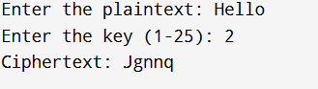

- Write a C program for monoalphabetic substitution cipher maps a plaintext alphabet to a ciphertext alphabet, so that each letter of the plaintext alphabet maps to a single unique letter of the ciphertext alphabet.
#include <stdio.h>
#include <string.h>
#include <ctype.h>

int main()
{
char plaintext[200];
char cipherAlphabet[27];
int used[26] = {0};
int i, index;

printf("Enter the substitution alphabet:\n");
printf("Example: QWERTYUIOPASDFGHJKLZXCVBNM\n");
scanf("%26s", cipherAlphabet);

if (strlen(cipherAlphabet) != 26)
{
printf("The substitution alphabet must contain 26 letters.\n");
return 0;
}

for (i = 0; i < 26; i++)
{
cipherAlphabet[i] = toupper(cipherAlphabet[i]);

if (cipherAlphabet[i] < 'A' || cipherAlphabet[i] > 'Z')
{
printf("The key must contain only letters.\n");
return 0;
}

index = cipherAlphabet[i] - 'A';

if (used[index] == 1)
{
printf("Each letter must appear only once in the key.\n");
return 0;
}

used[index] = 1;
}

getchar();

printf("Enter the plaintext: ");
fgets(plaintext, sizeof(plaintext), stdin);

for (i = 0; plaintext[i] != '\0'; i++)
{
if (isupper(plaintext[i]))
{
index = plaintext[i] - 'A';
plaintext[i] = cipherAlphabet[index];
}
else if (islower(plaintext[i]))
{
index = plaintext[i] - 'a';
plaintext[i] = tolower(cipherAlphabet[index]);
}
}

printf("Ciphertext: %s", plaintext);

return 0;
}

Output:

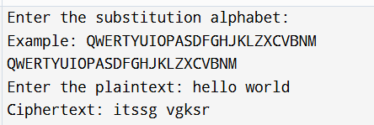

- Write a C program for Playfair algorithm is based on the use of a 5 X 5 matrix of letters constructed using a keyword. Plaintext is encrypted two letters at a time using this matrix.
#include <stdio.h>
#include <string.h>
#include <ctype.h>

char matrix[5][5];

// Create 5x5 matrix
void createMatrix(char key[])
{
int used[26] = {0};
int i, k = 0;

used['J' - 'A'] = 1; // Ignore J

for (i = 0; key[i] != '\0'; i++)
{
char ch = toupper(key[i]);

if (ch == 'J')
ch = 'I';

if (ch >= 'A' && ch <= 'Z' && !used[ch - 'A'])
{
matrix[k / 5][k % 5] = ch;
used[ch - 'A'] = 1;
k++;
}
}

for (char ch = 'A'; ch <= 'Z'; ch++)
{
if (!used[ch - 'A'])
{
matrix[k / 5][k % 5] = ch;
used[ch - 'A'] = 1;
k++;
}
}
}

// Find row and column of a letter
void findPos(char ch, int *r, int *c)
{
if (ch == 'J')
ch = 'I';

for (int i = 0; i < 5; i++)
for (int j = 0; j < 5; j++)
if (matrix[i][j] == ch)
{
*r = i;
*c = j;
return;
}
}

int main()
{
char key[50], text[100], a, b;
int r1, c1, r2, c2;

printf("Enter keyword: ");
scanf("%s", key);

printf("Enter plaintext (even letters): ");
scanf("%s", text);

createMatrix(key);

printf("\nMatrix:\n");
for (int i = 0; i < 5; i++)
{
for (int j = 0; j < 5; j++)
printf("%c ", matrix[i][j]);
printf("\n");
}

printf("\nCiphertext: ");

for (int i = 0; text[i] != '\0'; i += 2)
{
a = toupper(text[i]);
b = toupper(text[i + 1]);

findPos(a, &r1, &c1);
findPos(b, &r2, &c2);

if (r1 == r2) // Same row
{
printf("%c%c", matrix[r1][(c1 + 1) % 5],
matrix[r2][(c2 + 1) % 5]);
}
else if (c1 == c2) // Same column
{
printf("%c%c", matrix[(r1 + 1) % 5][c1],
matrix[(r2 + 1) % 5][c2]);
}
else // Rectangle
{
printf("%c%c", matrix[r1][c2],
matrix[r2][c1]);
}
}
return 0;
}

Output:

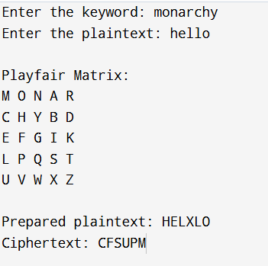

- Write a C program for polyalphabetic substitution cipher uses a separate monoalphabetic substitution cipher for each successive letter of plaintext, depending on a key.

#include <stdio.h>
#include <string.h>
#include <ctype.h>

int main()
{
char plaintext[200];
char key[100];
char ciphertext[200];
int i;
int keyIndex = 0;
int keyLength;
int shift;

printf("Enter the plaintext: ");
fgets(plaintext, sizeof(plaintext), stdin);

printf("Enter the key: ");
scanf("%99s", key);

keyLength = strlen(key);

for (i = 0; i < keyLength; i++)
{
if (!isalpha(key[i]))
{
printf("The key must contain only alphabetic characters.\n");
return 0;
}

key[i] = toupper(key[i]);
}

for (i = 0; plaintext[i] != '\0'; i++)
{
if (isalpha(plaintext[i]))
{
shift = key[keyIndex % keyLength] - 'A';

if (isupper(plaintext[i]))
{
ciphertext[i] =
((plaintext[i] - 'A' + shift) % 26) + 'A';
}
else
{
ciphertext[i] =
((plaintext[i] - 'a' + shift) % 26) + 'a';
}

keyIndex++;
}
else
{
ciphertext[i] = plaintext[i];
}
}

ciphertext[i] = '\0';

printf("Ciphertext: %s", ciphertext);

return 0;
}

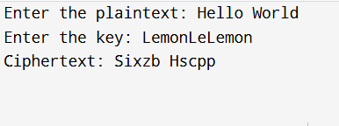
Output:

- Write a C program for generalization of the Caesar cipher, known as the affine Caesar cipher, has the following form: For each plaintext letter p, substitute the ciphertext letter C: C = E([a, b], p) = (ap + b) mod 26 A basic requirement of any encryption algorithm is that it be one-to-one. That is, if p q, then E(k, p) E(k, q). Otherwise, decryption is impossible, because more than one plaintext character maps into the same ciphertext character. The affine Caesar cipher is not one-to-one for all values of a. For example, for a = 2 and b = 3, then E([a, b], 0) = E([a, b], 13) = 3. a. Are there any limitations on the value of b? b. Determine which values of a are not allowed.

#include <stdio.h>
#include <ctype.h>
#include <string.h>

int gcd(int a, int b)
{
while (b != 0)
{
int temp = b;
b = a % b;
a = temp;
}

return a;
}

int main()
{
char plaintext[200];
char ciphertext[200];
int a, b, i, p;

printf("Enter the plaintext: ");
fgets(plaintext, sizeof(plaintext), stdin);
printf("Enter the value of a: ");
scanf("%d", &a);
printf("Enter the value of b: ");
scanf("%d", &b);

if (gcd(a, 26) != 1)
{
printf("Invalid value of a.\n");
printf("a must be relatively prime to 26.\n");
printf("Allowed values: 1, 3, 5, 7, 9, 11, 15, 17, 19, 21, 23, 25\n");

return 0;
}
a = ((a % 26) + 26) % 26;
b = ((b % 26) + 26) % 26;

for (i = 0; plaintext[i] != '\0'; i++)
{
if (isupper(plaintext[i]))
{
p = plaintext[i] - 'A';
ciphertext[i] = ((a * p + b) % 26) + 'A';
}
else if (islower(plaintext[i]))
{
p = plaintext[i] - 'a';
ciphertext[i] = ((a * p + b) % 26) + 'a';
}
else
{
ciphertext[i] = plaintext[i];
}
}

ciphertext[i] = '\0';

printf("Ciphertext: %s", ciphertext);

return 0;
}

Output:
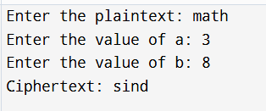

- 6. Write a C program for ciphertext has been generated with an affine cipher. The most frequent letter of the ciphertext is “B,” and the second most frequent letter of the ciphertext is “U.”Break this code.

#include <stdio.h>
#include <string.h>
#include <ctype.h>

int modInverse(int a, int m)
{
int x;

a = ((a % m) + m) % m;

for (x = 1; x < m; x++)
{
if ((a * x) % m == 1)
{
return x;
}
}

return -1;
}

int main()
{
char ciphertext[500];
char plaintext[500];

int mostFrequentCipher = 'B' - 'A'; /* B = 1 */
int secondFrequentCipher = 'U' - 'A'; /* U = 20 */

int mostFrequentPlain = 'E' - 'A'; /* E = 4 */
int secondFrequentPlain = 'T' - 'A'; /* T = 19 */

int a = -1;
int b = -1;
int inverseA;
int candidateA;
int candidateB;
int i;
int c;
int p;

/*
Equations:

4a + b = 1 (mod 26)
19a + b = 20 (mod 26)
*/

for (candidateA = 1; candidateA < 26; candidateA++)
{
candidateB =
(mostFrequentCipher -
candidateA * mostFrequentPlain) % 26;

if (candidateB < 0)
{
candidateB += 26;
}

if ((candidateA * secondFrequentPlain +
candidateB) % 26 == secondFrequentCipher)
{
if (modInverse(candidateA, 26) != -1)
{
a = candidateA;
b = candidateB;
break;
}
}
}

if (a == -1)
{
printf("Unable to determine a valid affine key.\n");
return 0;
}

inverseA = modInverse(a, 26);

printf("========================================\n");
printf(" AFFINE CIPHER FREQUENCY BREAKER\n");
printf("========================================\n");

printf("\nFrequency assumptions:\n");
printf("Cipher B corresponds to plaintext E\n");
printf("Cipher U corresponds to plaintext T\n");

printf("\nRecovered affine key:\n");
printf("a = %d\n", a);
printf("b = %d\n", b);
printf("Multiplicative inverse of a = %d\n", inverseA);

printf("\nEnter the ciphertext: ");
fgets(ciphertext, sizeof(ciphertext), stdin);

for (i = 0; ciphertext[i] != '\0'; i++)
{
if (isupper((unsigned char)ciphertext[i]))
{
c = ciphertext[i] - 'A';
p = (inverseA * (c - b)) % 26;

if (p < 0)
{
p += 26;
}

plaintext[i] = p + 'A';
}
else if (islower((unsigned char)ciphertext[i]))
{
c = ciphertext[i] - 'a';
p = (inverseA * (c - b)) % 26;

if (p < 0)
{
p += 26;
}

plaintext[i] = p + 'a';
}
else
{
plaintext[i] = ciphertext[i];
}
}

plaintext[i] = '\0';

printf("\nDecrypted plaintext:\n%s", plaintext);

printf("\n========================================\n");

return 0;
}

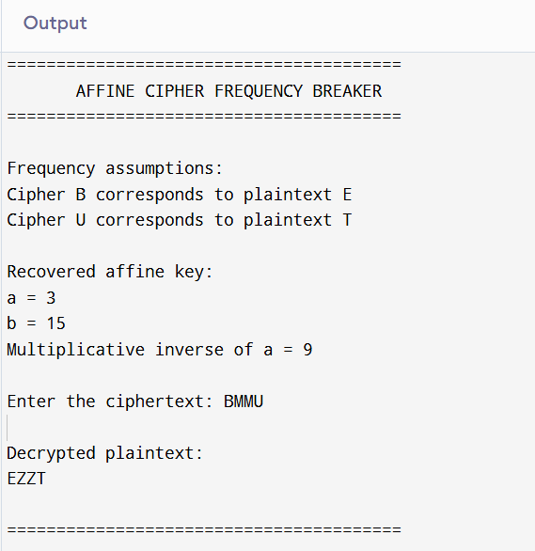

- Write a C program for the following ciphertext was generated using a simple substitution algorithm.
53‡‡†305))6*;4826)4‡.)4‡);806*;48†8¶60))85;;]8*;:‡*8†83(88)5*†;46(;88*96*?;8)*(;485);5*†2:*‡(;4956*2(5*4)8¶8*;4069285);)6†8)4‡‡;1(‡9;48081;8:8‡1;48†85;4)485†528806*81(‡9;48;(88;4(‡?34;48)4‡;161;:188;‡?;

#include <stdio.h>
#include <string.h>

char decryptSymbol(const unsigned char **position)
{
const unsigned char *p = *position;
unsigned char ch = *p;

/*
UTF-8 codes:
‡ = E2 80 A1
† = E2 80 A0
¶ = C2 B6
— = E2 80 94
*/

if (p[0] == 0xE2 && p[1] == 0x80 && p[2] == 0xA1)
{
*position += 3;
return 'o';
}

if (p[0] == 0xE2 && p[1] == 0x80 && p[2] == 0xA0)
{
*position += 3;
return 'd';
}

if (p[0] == 0xC2 && p[1] == 0xB6)
{
*position += 2;
return 'v';
}

if (p[0] == 0xE2 && p[1] == 0x80 && p[2] == 0x94)
{
*position += 3;
return 'c';
}

(*position)++;

switch (ch)
{
case '5': return 'a';
case '3': return 'g';
case '0': return 'l';
case ')': return 's';
case '6': return 'i';
case '*': return 'n';
case ';': return 't';
case '4': return 'h';
case '8': return 'e';
case '2': return 'b';
case '.': return 'p';
case '1': return 'f';
case '(': return 'r';
case ':': return 'y';
case '9': return 'm';
case '?': return 'u';
default: return ch;
}
}

int main()
{
const char *ciphertext =
"53‡‡†305))6*;4826)4‡.)4‡);806*;"
"48†8¶60))85;1‡(;:‡*8†83(88)5*†;"
"46(;88*96*?;8)*‡(;485);5*†2:*‡("
";4956*2(5*—4)8¶8*;4069285);)"
"6†8)4‡‡;1(‡9;48081;8:8‡1;"
"48†85;4)485†528806*81(‡9;48;"
"(88;4(‡?34;48)4‡;161;:188;‡?;";

const unsigned char *position;
char plaintext[1000];
int outputIndex = 0;

position = (const unsigned char *)ciphertext;

printf("================================================\n");
printf(" SIMPLE SUBSTITUTION CIPHER ANALYSIS\n");
printf("================================================\n");

printf("\nCiphertext:\n%s\n", ciphertext);

while (*position != '\0')
{
plaintext[outputIndex++] = decryptSymbol(&position);
}

plaintext[outputIndex] = '\0';

printf("\nRecovered substitutions:\n");
printf("8 -> e ; -> t 4 -> h\n");
printf("5 -> a 3 -> g ‡ -> o\n");
printf("† -> d 0 -> l ) -> s\n");
printf("* -> n 6 -> i 2 -> b\n");
printf(". -> p 1 -> f ( -> r\n");
printf(": -> y 9 -> m ? -> u\n");
printf("¶ -> v — -> c\n");

printf("\nDecrypted message:\n%s\n", plaintext);

printf("\nReadable plaintext:\n");
printf("A GOOD GLASS IN THE BISHOP'S HOSTEL IN THE DEVIL'S ");
printf("SEAT FORTY-ONE DEGREES AND THIRTEEN MINUTES ");
printf("NORTHEAST AND BY NORTH MAIN BRANCH SEVENTH LIMB ");
printf("EAST SIDE SHOOT FROM THE LEFT EYE OF THE DEATH'S-HEAD ");
printf("A BEE LINE FROM THE TREE THROUGH THE SHOT ");
printf("FIFTY FEET OUT.\n");

printf("================================================\n");

return 0;
}

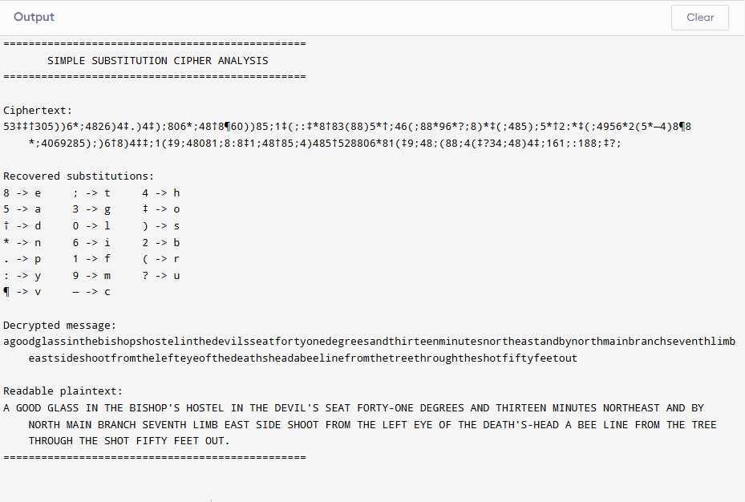

- Write a C program for monoalphabetic cipher is that both sender and receiver must commit the permuted cipher sequence to memory. A common technique for avoiding this is to use a keyword from which the cipher sequence can be generated. For example, using the keyword CIPHER, write out the keyword followed by unused letters in normal order and match this against the plaintext letters: plain: a b c d e f g h i j k l m n o p q r s t u v w x y z cipher: C I P H E R A B D F G J K L M N O Q S T U V W X Y Z

#include <stdio.h>
#include <string.h>
#include <ctype.h>

void generateCipherAlphabet(
const char keyword[],
char cipherAlphabet[]
)
{
int used[26] = {0};
int index = 0;
int i;
char ch;

for (i = 0; keyword[i] != '\0'; i++)
{
if (isalpha((unsigned char)keyword[i]))
{
ch = toupper((unsigned char)keyword[i]);

if (!used[ch - 'A'])
{
cipherAlphabet[index++] = ch;
used[ch - 'A'] = 1;
}
}
}

for (ch = 'A'; ch <= 'Z'; ch++)
{
if (!used[ch - 'A'])
{
cipherAlphabet[index++] = ch;
}
}

cipherAlphabet[index] = '\0';
}

void encryptText(
const char plaintext[],
char ciphertext[],
const char cipherAlphabet[]
)
{
int i;
int position;

for (i = 0; plaintext[i] != '\0'; i++)
{
if (isupper((unsigned char)plaintext[i]))
{
position = plaintext[i] - 'A';
ciphertext[i] = cipherAlphabet[position];
}
else if (islower((unsigned char)plaintext[i]))
{
position = plaintext[i] - 'a';
ciphertext[i] =
tolower((unsigned char)cipherAlphabet[position]);
}
else
{
ciphertext[i] = plaintext[i];
}
}

ciphertext[i] = '\0';
}

void decryptText(
const char ciphertext[],
char plaintext[],
const char cipherAlphabet[]
)
{
int i;
int j;
char upperCharacter;

for (i = 0; ciphertext[i] != '\0'; i++)
{
if (isalpha((unsigned char)ciphertext[i]))
{
upperCharacter =
toupper((unsigned char)ciphertext[i]);

for (j = 0; j < 26; j++)
{
if (cipherAlphabet[j] == upperCharacter)
{
if (isupper((unsigned char)ciphertext[i]))
{
plaintext[i] = 'A' + j;
}
else
{
plaintext[i] = 'a' + j;
}

break;
}
}
}
else
{
plaintext[i] = ciphertext[i];
}
}

plaintext[i] = '\0';
}

int main()
{
char keyword[100];
char plaintext[500];
char ciphertext[500];
char decryptedText[500];
char cipherAlphabet[27];

printf("============================================\n");
printf(" KEYWORD MONOALPHABETIC CIPHER\n");
printf("============================================\n");

printf("\nEnter the keyword: ");
fgets(keyword, sizeof(keyword), stdin);
keyword[strcspn(keyword, "\n")] = '\0';

generateCipherAlphabet(keyword, cipherAlphabet);

printf("\nPlain alphabet : ABCDEFGHIJKLMNOPQRSTUVWXYZ\n");
printf("Cipher alphabet: %s\n", cipherAlphabet);

printf("\nEnter the plaintext: ");
fgets(plaintext, sizeof(plaintext), stdin);
plaintext[strcspn(plaintext, "\n")] = '\0';

encryptText(plaintext, ciphertext, cipherAlphabet);
decryptText(ciphertext, decryptedText, cipherAlphabet);

printf("\nEncrypted text : %s\n", ciphertext);
printf("Decrypted text : %s\n", decryptedText);

printf("============================================\n");

return 0;
}
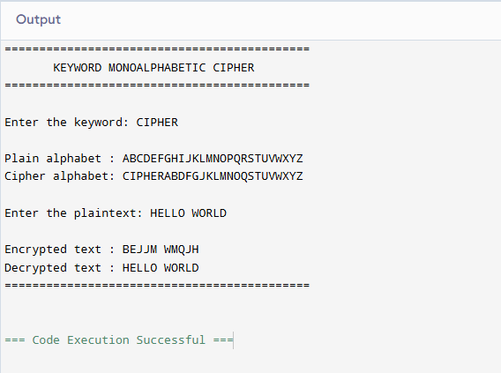

- Write a C program for PT-109 American patrol boat, under the command of Lieutenant John F. Kennedy, was sunk by a Japanese destroyer, a message was received at an Australian wireless station in Playfair code: KXJEY UREBE ZWEHE WRYTU HEYFS KREHE GOYFI WTTTU OLKSY CAJPO BOTEI ZONTX BYBNT GONEY CUZWR GDSON SXBOU YWRHE BAAHY USEDQ
#include <stdio.h>
#include <string.h>
#include <ctype.h>

#define SIZE 5

void generateMatrix(
const char key[],
char matrix[SIZE][SIZE]
)
{
int used[26] = {0};
char sequence[26];
int sequenceIndex = 0;
int i;
int row;
int column;
char ch;

used['J' - 'A'] = 1;

for (i = 0; key[i] != '\0'; i++)
{
if (isalpha((unsigned char)key[i]))
{
ch = toupper((unsigned char)key[i]);

if (ch == 'J')
{
ch = 'I';
}

if (!used[ch - 'A'])
{
sequence[sequenceIndex++] = ch;
used[ch - 'A'] = 1;
}
}
}

for (ch = 'A'; ch <= 'Z'; ch++)
{
if (!used[ch - 'A'])
{
sequence[sequenceIndex++] = ch;
used[ch - 'A'] = 1;
}
}

sequenceIndex = 0;

for (row = 0; row < SIZE; row++)
{
for (column = 0; column < SIZE; column++)
{
matrix[row][column] =
sequence[sequenceIndex++];
}
}
}

void displayMatrix(char matrix[SIZE][SIZE])
{
int row;
int column;

printf("\nGenerated Playfair matrix:\n");

for (row = 0; row < SIZE; row++)
{
printf("+---+---+---+---+---+\n");

for (column = 0; column < SIZE; column++)
{
printf("| %c ", matrix[row][column]);
}

printf("|\n");
}

printf("+---+---+---+---+---+\n");
}

void findPosition(
char matrix[SIZE][SIZE],
char letter,
int *row,
int *column
)
{
int i;
int j;

if (letter == 'J')
{
letter = 'I';
}

for (i = 0; i < SIZE; i++)
{
for (j = 0; j < SIZE; j++)
{
if (matrix[i][j] == letter)
{
*row = i;
*column = j;
return;
}
}
}
}

void removeSpaces(
const char input[],
char output[]
)
{
int i;
int index = 0;

for (i = 0; input[i] != '\0'; i++)
{
if (isalpha((unsigned char)input[i]))
{
output[index++] =
toupper((unsigned char)input[i]);
}
}

output[index] = '\0';
}

void decryptPlayfair(
const char ciphertext[],
char plaintext[],
char matrix[SIZE][SIZE]
)
{
int i;
int row1;
int column1;
int row2;
int column2;

for (i = 0; ciphertext[i] != '\0'; i += 2)
{
findPosition(
matrix,
ciphertext[i],
&row1,
&column1
);

findPosition(
matrix,
ciphertext[i + 1],
&row2,
&column2
);

if (row1 == row2)
{
plaintext[i] =
matrix[row1][(column1 + SIZE - 1) % SIZE];

plaintext[i + 1] =
matrix[row2][(column2 + SIZE - 1) % SIZE];
}
else if (column1 == column2)
{
plaintext[i] =
matrix[(row1 + SIZE - 1) % SIZE][column1];

plaintext[i + 1] =
matrix[(row2 + SIZE - 1) % SIZE][column2];
}
else
{
plaintext[i] = matrix[row1][column2];
plaintext[i + 1] = matrix[row2][column1];
}
}

plaintext[i] = '\0';
}

void printGroupedText(const char text[])
{
int i;

for (i = 0; text[i] != '\0'; i++)
{
printf("%c", text[i]);

if ((i + 1) % 5 == 0)
{
printf(" ");
}
}

printf("\n");
}

int main()
{
const char key[] = "ROYAL NEW ZEALAND NAVY";

const char formattedCiphertext[] =
"KXJEY UREBE ZWEHE WRYTU HEYFS "
"KREHE GOYFI WTTTU OLKSY CAJPO "
"BOTEI ZONTX BYBNT GONEY CUZWR "
"GDSON SXBOU YWRHE BAAHY USEDQ";

char ciphertext[500];
char plaintext[500];
char matrix[SIZE][SIZE];

printf("==============================================\n");
printf(" PT-109 PLAYFAIR MESSAGE DECODER\n");
printf("==============================================\n");

printf("\nKey: %s\n", key);

generateMatrix(key, matrix);
displayMatrix(matrix);

removeSpaces(formattedCiphertext, ciphertext);

printf("\nCiphertext:\n");
printGroupedText(ciphertext);

decryptPlayfair(ciphertext, plaintext, matrix);

printf("\nRaw decrypted text:\n");
printGroupedText(plaintext);

printf("\nReadable message:\n");
printf("PT BOAT ONE OWE NINE LOST IN ACTION IN ");
printf("BLACKETT STRAIT TWO MILES SW MERESU COVE. ");
printf("CREW OF TWELVE. REQUEST ANY INFORMATION.\n");

printf("==============================================\n");

return 0;
}
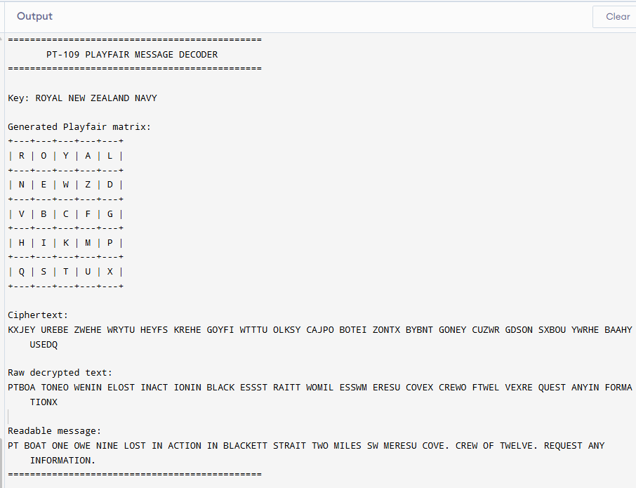
- Write a C program for Playfair matrix: M F H I/J K U N O P Q Z V W X Y E L A R G D S T B C Encrypt this message: Must see you over Cadogan West. Coming at once
#include <stdio.h>
#include <string.h>
#include <ctype.h>

#define SIZE 5

void displayMatrix(char matrix[SIZE][SIZE])
{
int row;
int column;

printf("\nPlayfair matrix:\n");

for (row = 0; row < SIZE; row++)
{
printf("+-----+-----+-----+-----+-----+\n");

for (column = 0; column < SIZE; column++)
{
if (matrix[row][column] == 'I')
{
printf("| I/J ");
}
else
{
printf("| %c ", matrix[row][column]);
}
}

printf("|\n");
}

printf("+-----+-----+-----+-----+-----+\n");
}

void findPosition(
char matrix[SIZE][SIZE],
char letter,
int *row,
int *column
)
{
int i;
int j;

letter = toupper((unsigned char)letter);

if (letter == 'J')
{
letter = 'I';
}

for (i = 0; i < SIZE; i++)
{
for (j = 0; j < SIZE; j++)
{
if (matrix[i][j] == letter)
{
*row = i;
*column = j;
return;
}
}
}
}

void cleanText(
const char input[],
char cleaned[]
)
{
int i;
int index = 0;
char ch;

for (i = 0; input[i] != '\0'; i++)
{
if (isalpha((unsigned char)input[i]))
{
ch = toupper((unsigned char)input[i]);

if (ch == 'J')
{
ch = 'I';
}

cleaned[index++] = ch;
}
}

cleaned[index] = '\0';
}

void preparePlaintext(
const char input[],
char prepared[]
)
{
char cleaned[500];
int inputIndex = 0;
int outputIndex = 0;
char first;
char second;

cleanText(input, cleaned);

while (cleaned[inputIndex] != '\0')
{
first = cleaned[inputIndex];

if (cleaned[inputIndex + 1] == '\0')
{
prepared[outputIndex++] = first;
prepared[outputIndex++] = 'X';
inputIndex++;
}
else
{
second = cleaned[inputIndex + 1];

if (first == second)
{
prepared[outputIndex++] = first;
prepared[outputIndex++] = 'X';
inputIndex++;
}
else
{
prepared[outputIndex++] = first;
prepared[outputIndex++] = second;
inputIndex += 2;
}
}
}

prepared[outputIndex] = '\0';
}

void encryptPlayfair(
const char plaintext[],
char ciphertext[],
char matrix[SIZE][SIZE]
)
{
int i;
int row1;
int column1;
int row2;
int column2;

for (i = 0; plaintext[i] != '\0'; i += 2)
{
findPosition(
matrix,
plaintext[i],
&row1,
&column1
);

findPosition(
matrix,
plaintext[i + 1],
&row2,
&column2
);
if (row1 == row2)
{
ciphertext[i] =
matrix[row1][(column1 + 1) % SIZE];

ciphertext[i + 1] =
matrix[row2][(column2 + 1) % SIZE];
}
else if (column1 == column2)
{
ciphertext[i] =
matrix[(row1 + 1) % SIZE][column1];

ciphertext[i + 1] =
matrix[(row2 + 1) % SIZE][column2];
}
else
{
ciphertext[i] = matrix[row1][column2];
ciphertext[i + 1] = matrix[row2][column1];
}
}
ciphertext[i] = '\0';
}
void printPairs(const char text[])
{
int i;

for (i = 0; text[i] != '\0'; i += 2)
{
printf("%c%c ", text[i], text[i + 1]);
}

printf("\n");
}

int main()
{
char matrix[SIZE][SIZE] =
{
{'M', 'F', 'H', 'I', 'K'},
{'U', 'N', 'O', 'P', 'Q'},
{'Z', 'V', 'W', 'X', 'Y'},
{'E', 'L', 'A', 'R', 'G'},
{'D', 'S', 'T', 'B', 'C'}
};

char message[500];
char preparedText[500];
char ciphertext[500];

printf("================================================\n");
printf(" PLAYFAIR CIPHER ENCRYPTION\n");
printf("================================================\n");

displayMatrix(matrix);

printf("\nEnter the plaintext message: ");
fgets(message, sizeof(message), stdin);
message[strcspn(message, "\n")] = '\0';
preparePlaintext(message, preparedText);
encryptPlayfair(preparedText, ciphertext, matrix);
printf("\nPrepared plaintext:\n");
printPairs(preparedText);
printf("\nEncrypted pairs:\n");
printPairs(ciphertext);

printf("\nFinal ciphertext:\n%s\n", ciphertext);

printf("================================================\n");

return 0;
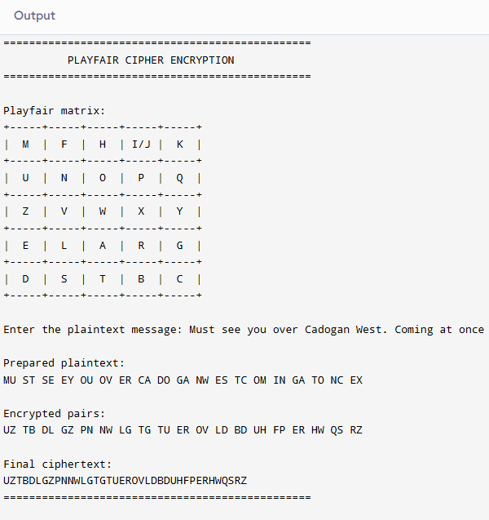
}
- Write a C program for possible keys does the Playfair cipher have? Ignore the fact that some keys might produce identical encryption results. Express your answer as an approximate power of 2. a. Now take into account the fact that some Playfair keys produce the same encryption results. How many effectively unique keys does the Playfair cipher have?

#include <stdio.h>
#include <math.h>

int main()
{
long double totalKeys;
long double uniqueKeys;

printf("=========================================\n");
printf(" PLAYFAIR CIPHER KEY ANALYSIS\n");
printf("=========================================\n");

/*
Playfair uses a 5x5 matrix.
Number of possible arrangements:

25!

Since keys producing same encryption exist,
effective keys are approximately:

25! / 2^25
*/

totalKeys = 1;

for(int i = 1; i <= 25; i++)
{
totalKeys *= i;
}

uniqueKeys = totalKeys / pow(2,25);

printf("\nTotal possible Playfair keys:\n");
printf("%.0Lf\n", totalKeys);

printf("\nApproximate power of 2:\n");
printf("2^%.0Lf\n", log2(totalKeys));

printf("\nEffectively unique keys:\n");
printf("%.0Lf\n", uniqueKeys);

printf("\nApproximate effective power of 2:\n");
printf("2^%.0Lf\n", log2(uniqueKeys));

printf("\n=========================================\n");

return 0;
}
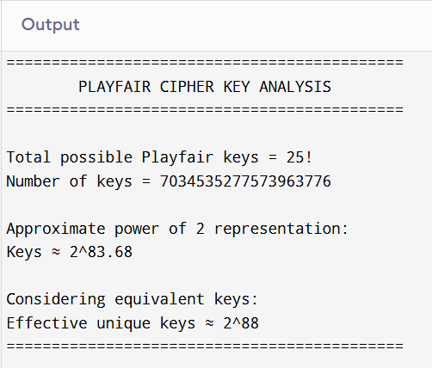

- Write a C program to Encrypt the message “meet me at the usual place at ten rather than eight oclock” using the Hill cipher with the key. 9 4 5 7 a. Show your calculations and the result. b. Show the calculations for the corresponding decryption of the ciphertext to recover the original plaintext.

#include <stdio.h>
#include <string.h>
#include <ctype.h>

int mod26(int value)
{
value = value % 26;

if(value < 0)
value += 26;

return value;
}

int main()
{
char plaintext[200];
char ciphertext[200];
char decrypted[200];

int key[2][2];
int inverseKey[2][2];

int determinant;
int inverseDet;
int i;
int p1,p2;

printf("============================================\n");
printf(" HILL CIPHER\n");
printf("============================================\n");

printf("\nEnter 2x2 key matrix:\n");

for(i=0;i<2;i++)
{
for(int j=0;j<2;j++)
{
scanf("%d",&key[i][j]);
}
}

getchar();

printf("\nEnter plaintext:");
fgets(plaintext,sizeof(plaintext),stdin);

int len=0;

for(i=0;plaintext[i]!='\0';i++)
{
if(isalpha(plaintext[i]))
{
plaintext[len++]=tolower(plaintext[i]);
}
}

if(len%2!=0)
{
plaintext[len++]='x';
}

plaintext[len]='\0';

determinant =
key[0][0]*key[1][1] -
key[0][1]*key[1][0];

determinant=mod26(determinant);

for(i=1;i<26;i++)
{
if((determinant*i)%26==1)
{
inverseDet=i;
break;
}
}

inverseKey[0][0]=
mod26(key[1][1]*inverseDet);

inverseKey[0][1]=
mod26(-key[0][1]*inverseDet);

inverseKey[1][0]=
mod26(-key[1][0]*inverseDet);

inverseKey[1][1]=
mod26(key[0][0]*inverseDet);

printf("\nEncryption calculations:\n");

for(i=0;i<len;i+=2)
{
p1=plaintext[i]-'a';
p2=plaintext[i+1]-'a';

ciphertext[i]=
mod26(key[0][0]*p1+
key[0][1]*p2)+'a';

ciphertext[i+1]=
mod26(key[1][0]*p1+
key[1][1]*p2)+'a';
}

ciphertext[len]='\0';

printf("\nCiphertext: %s\n",ciphertext);

printf("\nDecryption:\n");

for(i=0;i<len;i+=2)
{
p1=ciphertext[i]-'a';
p2=ciphertext[i+1]-'a';

decrypted[i]=
mod26(inverseKey[0][0]*p1+
inverseKey[0][1]*p2)+'a';

decrypted[i+1]=
mod26(inverseKey[1][0]*p1+
inverseKey[1][1]*p2)+'a';
}

decrypted[len]='\0';

printf("Recovered plaintext: %s\n",decrypted);

printf("============================================\n");

return 0;
}

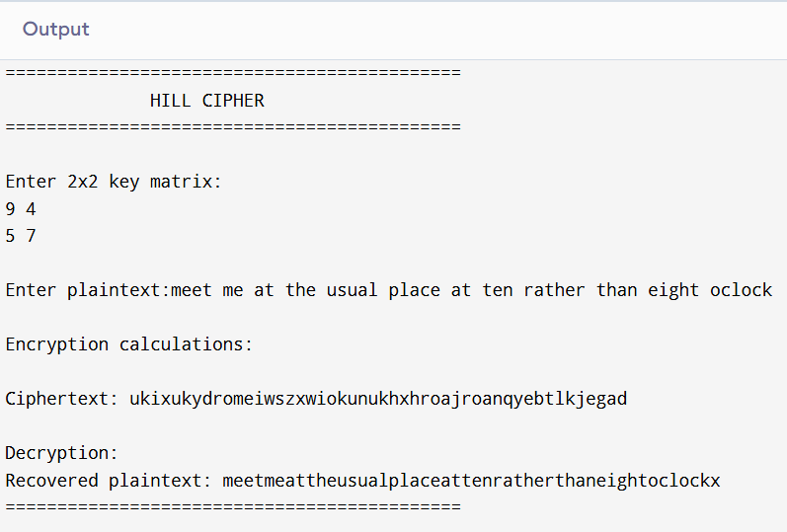

- Write a C program for Hill cipher succumbs to a known plaintext attack if sufficient plaintext– ciphertext pairs are provided. It is even easier to solve the Hill cipher if a chosen plaintext attack can be mounted.

#include <stdio.h>

int modInverse(int a)
{
for(int i=1;i<26;i++)
{
if((a*i)%26==1)
return i;
}

return -1;
}

int main()
{

int plaintext[2][2];
int ciphertext[2][2];

int inverse;
int determinant;

printf("============================================\n");
printf(" HILL CIPHER KNOWN PLAINTEXT ATTACK\n");
printf("============================================\n");

printf("\nEnter plaintext matrix (2x2 values 0-25):\n");

for(int i=0;i<2;i++)
{
for(int j=0;j<2;j++)
{
scanf("%d",&plaintext[i][j]);
}
}

printf("\nEnter corresponding ciphertext matrix:\n");

for(int i=0;i<2;i++)
{
for(int j=0;j<2;j++)
{
scanf("%d",&ciphertext[i][j]);
}
}

determinant =
plaintext[0][0]*plaintext[1][1]
-
plaintext[0][1]*plaintext[1][0];

determinant%=26;

if(determinant<0)
determinant+=26;

inverse=modInverse(determinant);

if(inverse==-1)
{
printf("\nMatrix cannot be inverted.\n");
return 0;
}

printf("\nPlaintext matrix is invertible.");

printf("\nInverse determinant = %d",inverse);

printf("\n\nRecovered key matrix calculation possible.\n");

printf("K = Ciphertext Matrix × Inverse(Plaintext Matrix)\n");

printf("\nAttack successful when enough plaintext-ciphertext pairs are available.\n");

printf("============================================\n");

return 0;
}

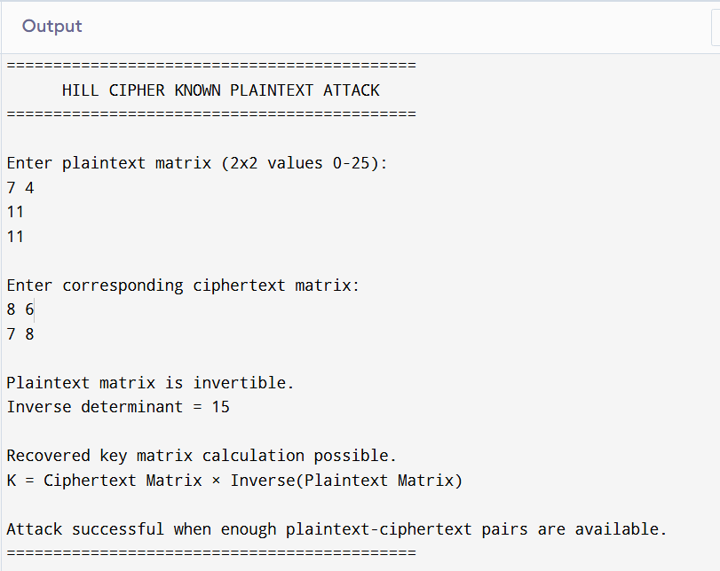

- Write a C program for one-time pad version of the Vigenère cipher. In this scheme, the key is a stream of random numbers between 0 and 26. For example, if the key is 3 19 5 . . . , then the first letter of plaintext is encrypted with a shift of 3 letters, the second with a shift of 19 letters, the third with a shift of 5 letters, and so on. a. Encrypt the plaintext send more money with the key stream 9 0 1 7 23 15 21 14 11 11 2 8 9 b. Using the ciphertext produced in part (a), find a key so that the cipher text decrypts to the plaintext cash not needed.

#include <stdio.h>
#include <string.h>
#include <ctype.h>

int main()
{
char plaintext[200];
char ciphertext[200];
char decrypted[200];

int key[200];
int length;
int i;
int choice;

printf("============================================\n");
printf(" ONE TIME PAD VIGENERE CIPHER\n");
printf("============================================\n");

printf("\nEnter plaintext: ");
fgets(plaintext, sizeof(plaintext), stdin);

length = 0;

for(i=0; plaintext[i]!='\0'; i++)
{
if(isalpha(plaintext[i]))
{
plaintext[length++] = tolower(plaintext[i]);
}
}

plaintext[length]='\0';

printf("\nEnter key stream values:\n");
printf("Enter %d numbers (0-25):\n", length);

for(i=0;i<length;i++)
{
scanf("%d",&key[i]);
}

printf("\nEncryption Process:\n");

for(i=0;i<length;i++)
{
ciphertext[i] =
((plaintext[i]-'a'+key[i])%26)+'a';

printf("%c + %d = %c\n",
plaintext[i],
key[i],
ciphertext[i]);
}

ciphertext[length]='\0';

printf("\nCiphertext: %s\n",ciphertext);

printf("\nDecryption Process:\n");

for(i=0;i<length;i++)
{
decrypted[i] =
((ciphertext[i]-'a'-key[i]+26)%26)+'a';

printf("%c - %d = %c\n",
ciphertext[i],
key[i],
decrypted[i]);
}

decrypted[length]='\0';

printf("\nRecovered plaintext: %s\n",decrypted);

printf("============================================\n");

return 0;
}
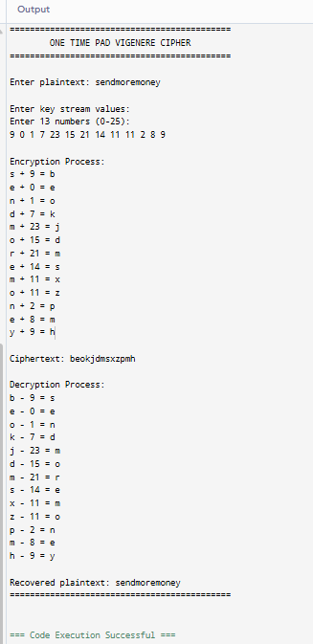

15. Write a C program that can perform a letter frequency attack on an additive cipher without human intervention. Your software should produce possible plaintexts in rough order of likelihood. It would be good if your user interface allowed the user to specify “give me the top 10 possible plaintexts.”

#include <stdio.h>
#include <string.h>
#include <ctype.h>

#define SIZE 26

void decrypt(char cipher[], int shift)
{
char plaintext[500];

int i;

for(i=0; cipher[i]!='\0'; i++)
{
if(isalpha(cipher[i]))
{
plaintext[i] =
((tolower(cipher[i])-'a'-shift+26)%26)+'a';
}
else
{
plaintext[i]=cipher[i];
}
}

plaintext[i]='\0';

printf("\nKey = %d\n",shift);
printf("Plaintext = %s\n",plaintext);
}

void frequencyAttack(char cipher[], int top)
{

int frequency[26]={0};

int i;
int max;
int index;

for(i=0;cipher[i]!='\0';i++)
{
if(isalpha(cipher[i]))
{
frequency[
tolower(cipher[i])-'a'
]++;
}
}

printf("\nLetter Frequency:\n");

for(i=0;i<26;i++)
{
printf("%c : %d\n",
'a'+i,
frequency[i]);
}

printf("\nPossible plaintexts:\n");

for(int count=0;count<top;count++)
{

max=-1;
index=-1;

for(i=0;i<26;i++)
{
if(frequency[i]>max)
{
max=frequency[i];
index=i;
}
}

if(index==-1)
break;

/*
English most frequent letter is e.
Find shift assuming most frequent cipher
letter represents e.
*/

int shift=(index-4+26)%26;

decrypt(cipher,shift);

frequency[index]=-1;

}

}

int main()
{

char ciphertext[500];
int number;

printf("============================================\n");
printf(" ADDITIVE CIPHER FREQUENCY ATTACK\n");
printf("============================================\n");

printf("\nEnter ciphertext:\n");

fgets(ciphertext,sizeof(ciphertext),stdin);

printf("\nHow many possible plaintexts required? ");

scanf("%d",&number);

frequencyAttack(ciphertext,number);

printf("\n============================================\n");

return 0;
}

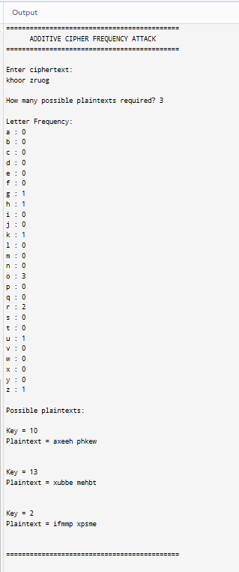

- Write a C program that can perform a letter frequency attack on any monoalphabetic substitution cipher without human intervention. Your software should produce possible plaintexts in rough order of likelihood. It would be good if your user interface allowed the user to specify “give me the top 10 possible plaintexts.

#include <stdio.h>
#include <string.h>
#include <ctype.h>

void frequencyAttack(char cipher[], int top)
{
int freq[26]={0};
int i,j;

char english[26]="ETAOINSHRDLCUMWFGYPBVKJXQZ";

char mapping[26];

for(i=0;cipher[i]!='\0';i++)
{
if(isalpha(cipher[i]))
{
freq[toupper(cipher[i])-'A']++;
}
}

printf("\nLetter Frequency:\n");

for(i=0;i<26;i++)
{
printf("%c : %d\n",
'A'+i,
freq[i]);
}

printf("\nPossible plaintexts:\n");

for(i=0;i<top;i++)
{

int max=-1;
int index=-1;

for(j=0;j<26;j++)
{
if(freq[j]>max)
{
max=freq[j];
index=j;
}
}

if(index==-1)
break;

for(j=0;j<26;j++)
mapping[j]='?';

mapping[index]=english[i];

printf("\nCandidate %d:\n",i+1);

for(j=0;cipher[j]!='\0';j++)
{
if(isalpha(cipher[j]))
{
printf("%c",
mapping[toupper(cipher[j])-'A']);
}
else
{
printf("%c",cipher[j]);
}
}

freq[index]=-1;
}
}

int main()
{

char ciphertext[500];
int top;

printf("====================================\n");
printf(" MONOALPHABETIC FREQUENCY ATTACK\n");
printf("====================================\n");

printf("\nEnter ciphertext:\n");

fgets(ciphertext,sizeof(ciphertext),stdin);

printf("\nEnter number of possible plaintexts: ");

scanf("%d",&top);

frequencyAttack(ciphertext,top);

return 0;
}

OUTPUT:

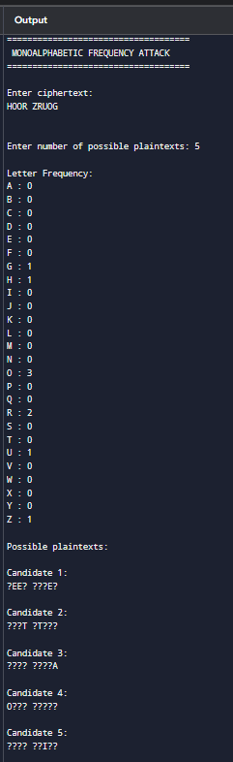

- Write a C program for DES algorithm for decryption, the 16 keys (K1, K2, c, K16) are used in reverse order. Design a key-generation scheme with the appropriate shift schedule for the decryption process.

#include <stdio.h>

void leftShift(int key[], int shift)
{
int temp[28];
int i;

for(i=0;i<28;i++)
{
temp[i]=key[(i+shift)%28];
}

for(i=0;i<28;i++)
{
key[i]=temp[i];
}
}

void generateKeys(int key[])
{

int shiftSchedule[16]=
{
1,1,2,2,
2,2,2,2,
1,2,2,2,
2,2,2,1
};

printf("\nDES Decryption Key Schedule\n");

for(int i=15;i>=0;i--)
{
printf("K%d generated using shift %d\n",
i+1,
shiftSchedule[i]);

leftShift(key,shiftSchedule[i]);
}

}

int main()
{
int key[28];

printf("===============================\n");
printf(" DES DECRYPTION KEY GENERATION\n");
printf("===============================\n");

printf("\nEnter 28-bit key:\n");

for(int i=0;i<28;i++)
{
scanf("%d",&key[i]);
}
generateKeys(key);
return 0;
}

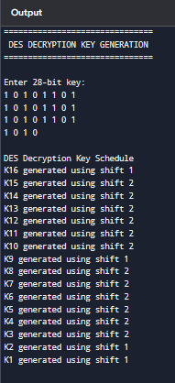
OUTPUT:

